The Specialist Education:
SEX & PORN ADDICTION THERAPIST
Many people watch pornography today.
The idea of watching other people have sex may seem harmless and inspiring – and in many cases, it can be. However, the industry has gained enormous influence, and we live in a more visual age than ever before.
Many people – particularly men – consume large amounts of pornography and become dependent on watching it daily or weekly. Many are not aware that they have developed an addiction. Pornography consumption and the pornography industry continue to grow rapidly. It is a profitable business.
If you are unsure whether you are addicted to pornography, try not watching it for three months. Do something else: go outside, build a relationship or go for a run.

Unfortunately, many people are negatively affected:
- A significant proportion of pornography contains some degree of psychological, physical or sexual violence.
- Young people and children may use pornography as sex education and consequently risk crossing their own boundaries or those of others.
- Some young people develop problematic pornography habits even before their first sexual experience.
- The pornography industry may reinforce unequal power relations. Much mainstream pornography is produced primarily for a male audience.

Positive Pornography
Pornography that does not contain violence, but instead portrays equality, consent and mutual pleasure, may contribute to greater openness and provide insight into different forms of sexuality and sexual orientation. It can help release sexuality from shame and guilt and support the idea that people of all genders have the right to experience desire, initiate sex and make conscious choices about their sexual lives.
However, this is not the type of pornography that dominates the industry. As a commercial industry, pornography benefits when users return repeatedly and develop increasingly habitual patterns of consumption.

Addiction, Dopamine & Escalation
As with other forms of addiction, pornography can activate the brain’s reward system and release dopamine. Over time, some people need more intense or extreme material to experience the same level of stimulation and satisfaction. This can create a downward spiral.
Many people have sexual fantasies that they do not wish to act out in real life. Some experience shame immediately after orgasm – not because orgasm is wrong, but because they feel disturbed by the pornography that aroused them while masturbating.
We also see people crossing one another’s boundaries, while others – especially young people – may allow their boundaries to be crossed because harmful behaviour has come to seem normal.
Sometimes they only realise in therapy that something is seriously wrong, or when their mental health or body begins to react – for example through vulvodynia, burning sensations or pain during intercourse.
Some young men find that they can no longer achieve an erection, become sufficiently aroused or reach orgasm during sex with a partner. They may experience emotional or physical numbness and feel dependent on pornography in order to climax.
Many sense that something is wrong, but shame and hopelessness prevent them from seeking help. As modern Sex & Porn Addiction Therapists, we want to help people address these challenges professionally, compassionately and without judgement.
Watch the pornography that you choose – but make sure that the people you are watching are safe and treated well, that your use does not become addictive, and that you can still enjoy satisfying sex and intimacy without pornography.

Assignments, Supervision & Lecture
Each student prepares, presents and delivers one lecture to a self-selected audience of at least 50 people. The lecture is also presented as part of the student presentation and at the Sexology Festival in week 41.
Each student is required to complete 3 hours of Supervision and 3 hours of study-group work per month – 18 hours in total.

Awareness in the World
We can contribute to greater awareness of sexuality, life and pornography, so that the choices you make are as conscious as possible – choices that you can feel happy about and proud of, both now and in the future.
Pornography can also be a source of inspiration without becoming an addiction – provided that the people portrayed are genuinely safe and well, both now and in the years to come.

Modules & Teaching Hours
The Specialist Education is delivered online and consists of 4 modules, including the examination.
- Modules 1, 2 and 3: Days 1 and 2 from 9:00 a.m. to 4:00 p.m.; Day 3 from 9:00 a.m. to 3:00 p.m.
- Module 4: Individual examination times will be announced no later than one month in advance.
- Attendance is mandatory. The maximum permitted absence – regardless of the reason – is 10% in order to qualify for the examination.
- Leave of absence is not available from the Specialist Educations.
Download the Module Overview, including the starting date, from the front page of the website.

Admission Requirements & Application
Admission to the Specialist Educations requires you to be enrolled in or admitted to the Sexologist Education at Sexologiskolen, preferably together with the RelationshipTherapist Education. You may complete the Specialist Educations either alongside the Main Education or after completing it.
Applicants who hold a Sexologist qualification from another school may also apply. Depending on their previous educational background, supplementary modules may be required. This is assessed individually. You are always welcome to contact us if you have any questions.
We recommend applying for admission no later than one year before your preferred starting date.

Application & Education Packages
The Application Form can be downloaded from the front page. It includes prices and payment options. The education may be paid in full or through an instalment plan.
Many students combine the Sexologist & RelationshipTherapist Main Education with 2–4 Specialist Educations, and a growing number also continue with the MasterResearcher Education. Simultaneous admission to several educations offers savings and the possibility of a longer payment period.
We therefore recommend an Education Package if you wish to deepen your expertise, invest in yourself and your future, and create meaningful work and a strong professional career.

Parallel Specialist Educations
When choosing your Specialist Educations, we encourage you to consider your interests and future ambitions – and to trust your intuition.
Specialist Educations that complement this education include:
- Didactic Sexologist
- Cultural Sexologist
- Trauma Therapist
- Youth Therapist
- Psychological Abuse Therapist
- Prison Therapist
- Single Therapist
- TantraYoga Teacher
- Erotic Tantra Teacher
- Meditation Teacher
You may also choose from any of the other 40 Specialist Educations offered by Sexologiskolen / IAS.

Online Teaching & Contact
Teaching is delivered online. Students may also meet at open events hosted by Sexologiskolen in Copenhagen and on Bornholm.
Sexologiskolen Bornholm – BohemianGarden
Kirkeskolevej 7, 3751 Østermarie, Bornholm, Denmark
Telephone: +45 77 888 888
Email: info@ias-education.com
Yazmin Fox – Direct contact
Telephone: +45 2670 5577
Email: info@ias-education.com
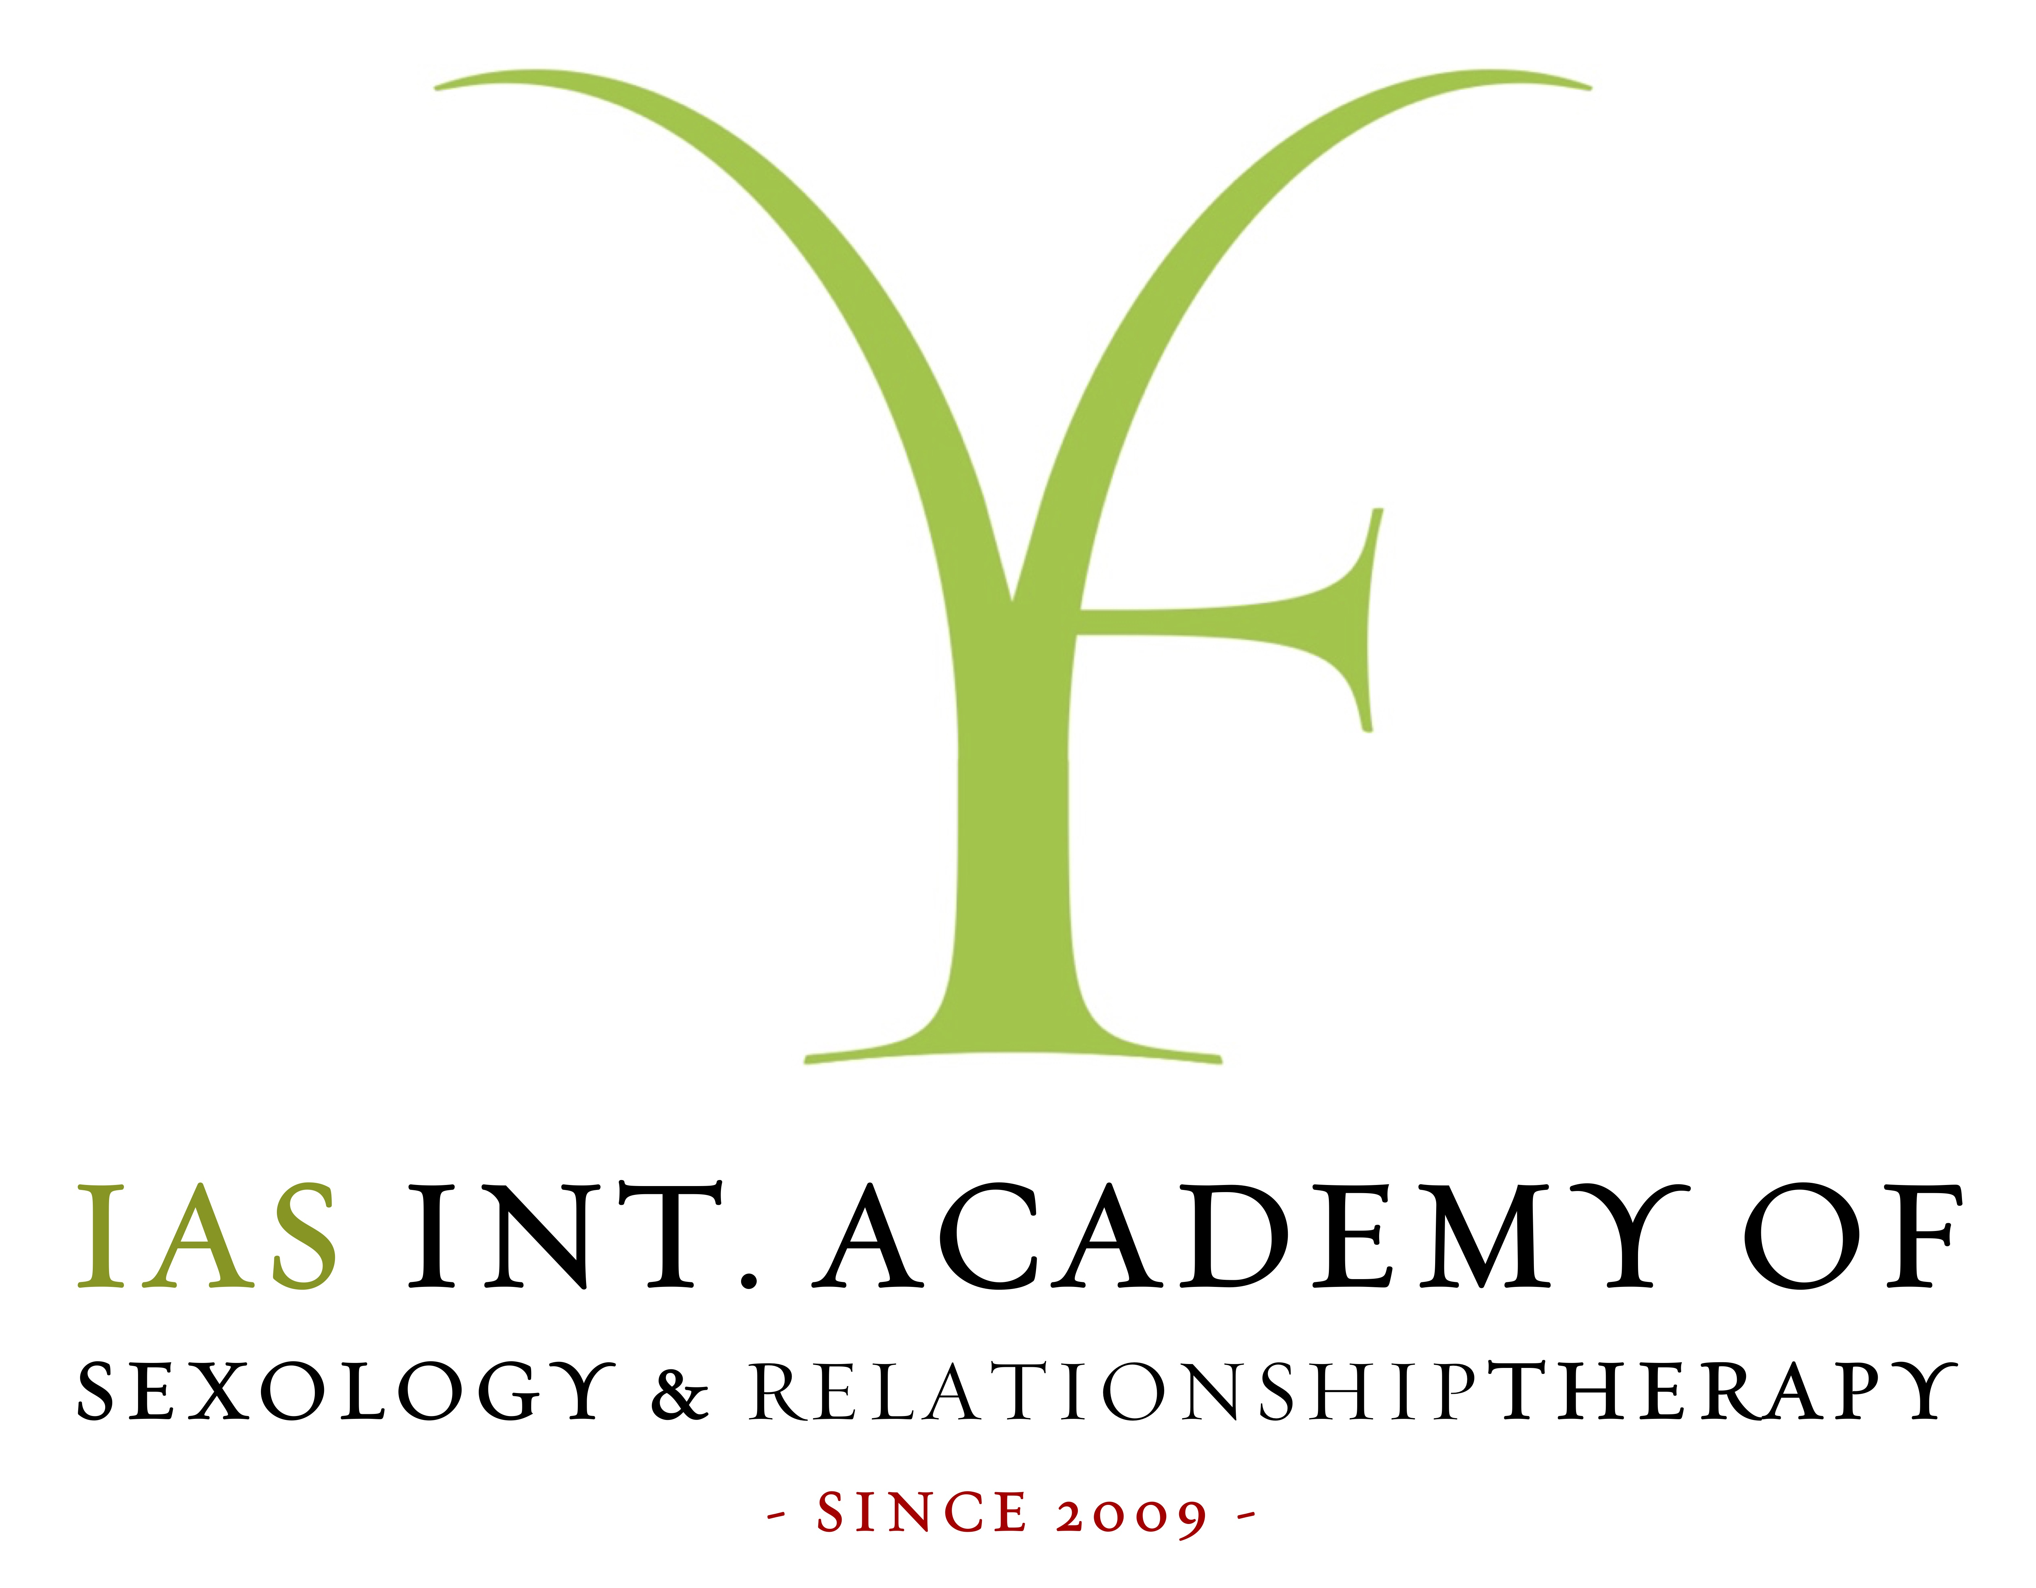
Source page: https://sexologiskolen.dk/kl/sex-og-pornoafhaengigheds-terapeut

