Application Form | IAS Int. Academy of Sexology & RelationshipTherapy - Global Line
Established in 2009 – One Academy, One Complete Career Pathway

The Main Education Sexologist & Relationship Therapist  The Research Education MasterResearcher  & more than 40 Specialist Educations

100% Online Study  With the option of free participation in two Summer Boarding School Modules in Bornholm, Denmark - with a Whole-Person focus!
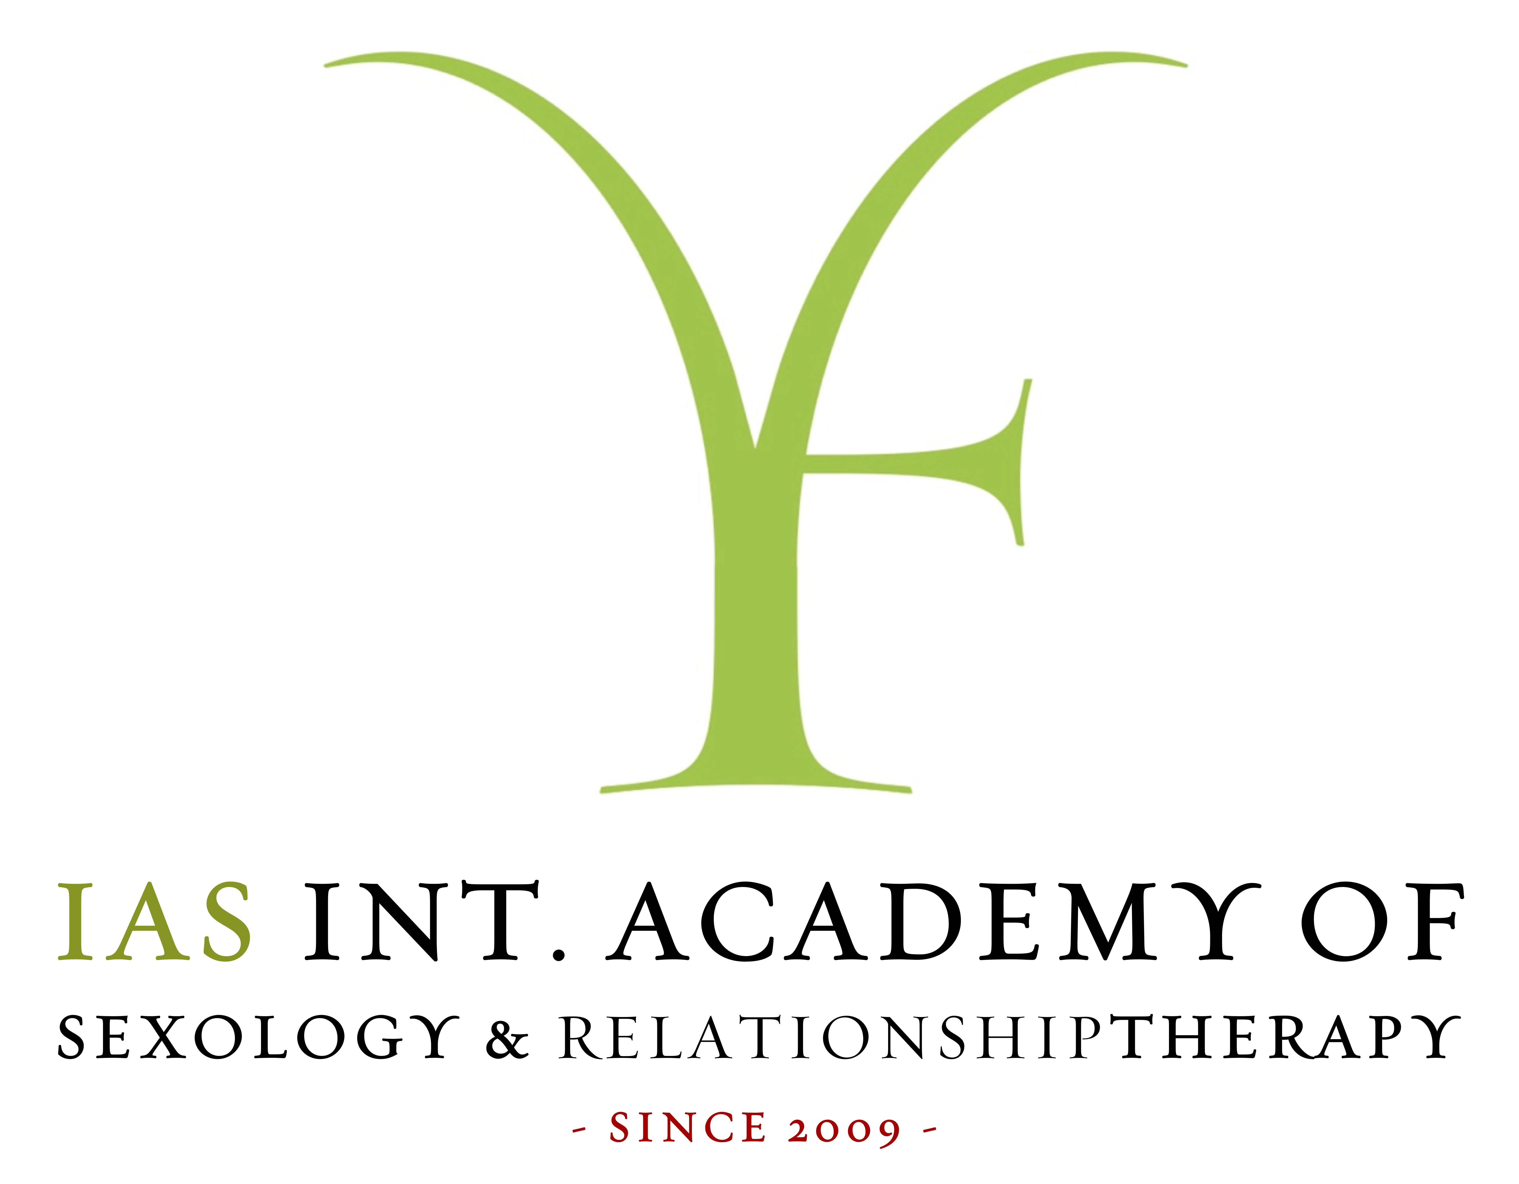

Name, Address & Age:

Nationality & Currently living in Country:

Phone number & Mail:

Photo, if you have:

How did you hear about the educations at IAS – International Academy of Sexology & Relationship Therapy?
Please specify where or through whom you were introduced to IAS (e.g. personal recommendation, Google search, reference code, social media, etc.):

Application – When & How?

- There is continuous enrollment for all Educations throughout the year. You can apply for any listed education.
- We recommend applying no later than 6 months - 1 year before your desired start date. Enrollment closes once the class is full.
- You are always welcome to email us and ask if there are available spots! It is possible to join up until Module 3, if space allows.

Main Education Global Line. Academic Years: 2026 - 2028.

You can also choose to Study 100% in English at our Global Line. The main education to “Sexologist & RelationshipTherapist” is a 2-year education comprising 26 modules of approximately 3 days each. One year focuses on Sexology (even years), and the other on Relationship Therapy (odd years). The education starts every year in September, and you may choose whether to begin with Sexology or RelationshipTherapy - it’s your choice! During the education, you have the opportunity to participate in two on-site Summer Boarding Modules at BohemianGarden on the beautiful Danish Island of Bornholm. Board and lodging are included in the tuition fee. You may also choose to participate 100% online. Please remember to mark (X) the year for which you are applying.

As part of IAS’ ongoing and successful international expansion, we are pleased to announce the launch of 🌎 Global Line – North America in September 2027, in addition to 🌍 Global Line – Europe. NB: RelationshipTherapist Education starting April 17, 2026.
This class will be the last intake where RelationshipTherapist can be studied as an independent education.

- RelationshipTherapist - April 17, 2026 (1½-year program):

- RelationshipTherapist & Sexologist - April 24, 2026 (1½-year program):

- Sexologist & Relationship Therapist - September 4 2026 (2-year program):

- Sexologist & Relationship Therapist - September 17 2027 (2-year program):

- Sexologist & Relationship Therapist - September 15 2028 (2-year program):

Research Education Global Line. Academic Year 2027 - 2029.
The Research Education, “MasterResearcher,” is a 2-year programme consisting of 13 modules, each lasting approximately 3 days.
The Education starts every second year (odd-numbered years) in January (Week 4). Language: English. Format: 100% online
You may begin the MasterResearcher Education as soon as you have completed the Sexologist & Relationship Therapist Education and have passed all examinations. Please remember to mark (X) the year you are applying for admission.

- MasterResearcher, January 29 2027:

- MasterResearcher, January 26 2029:

- MasterResearcher, January 24, 2031:

Specialist Educations Academic Years: 2026 - 2029
All 40 Int. Specialist Educations are part of the Int. Global Line and are taught in English. Most are delivered online, while others, that include physical exercises - are offered fully or partly on-site. You may apply for admission to one or several Specialist Educations.
A Specialist Education can be completed either alongside the Main Education or after completing it. Each Specialist Education is offered on average every third year. Please remember to mark (X) the Specialist Educations you are applying for admission to.

2026

32. Int. Supervisor – Individual & Group, May 8, 2026:

9. Int. Elderly Therapist, August 24, 2026:

25. Int. Sex- and Porn Addict Therapist, September 7, 2026:

2027

14. Int. Group Therapy Leader, January 11, 2027:

24. Int. Psychological Violence Therapist, January 11, 2027:

2. Int. Bonus Family Therapist, January 18, 2027:

8. Int. Divorce Therapist, January 18, 2027:

20. Int. MSPD (Mental Spectrum & Personality Disorder) Sexologist & Relationship Therapist, January 18, 2027:

27. Int. Single Therapist, January 25, 2027:

34. Int. Trauma Therapist, January 25, 2027:

1. Int. ArtSexologist & -Therapist, March 1, 2027:

18. Int. Meditation Teacher, March 1, 2027:

19. Int. MovieSexologist, March 1, 2027:

17. Int. Massage Therapist, March 8, 2027:

29. Int. Spiritual Leadership, March 8, 2027:

15. Int. Herbalogist – Ayurvedic, March 12, 2027:

5. Int. Detox Therapist, March 15, 2027:

35. Int. Vaginal Therapist, May 3, 2027:

6. Int. Didactic Sexologist, August 30, 2027:

7. Int. Disability Sexologist, September 6, 2027:

13. Int. Fertility Therapist, September 13, 2027:

2028

40. Int. Youth Therapist, January 10, 2028:

23. Int. Prison Therapist, January 17, 2028:

4. Int. Culture Sexologist & Relationship Therapist, January 24, 2028:

33. Int. Tantra Yoga Teacher, February 2, 2028:

12. Int. Fasting Therapist, March 6, 2028:

11. Int. Erotic Tantra Teacher, March 13, 2028:

32. Int. Supervisor – Individual & Group, May 8, 2028:

16. Int. LGBTQ+ Therapist, August 28, 2028:

10. Int. Equality Coach, September 4, 2028:

28. Int. Sleep Therapist, September 11, 2028:
2029

22. Int. Parent Relationship Therapist, January 8, 2029:

3. Int. Business Sexologist & Relationship Therapist, January 15, 2029:

26. Int. Sexological & Therapeutic Literature, January 22, 2029:

30. Int. Spiritual Realliance Therapist, February 26, 2029:

36. Int. Vegan, Vegetarian & Wholefood Diet Counselor, February 26, 2029:

37. Int. Vitality Therapist, March 5, 2029:

39. Int. Wellness Therapist, March 12, 2029:

38. Int. War & Crisis Therapist, August 27, 2029:

31. Int. Sports Therapist, September 3, 2029:

21. Int. Orgasmic Birth Coach, September 10, 2029:

About You

Background, Education & Experience

Educational Background & Life Learning Please share a bit about your background – whether academic, vocational, or life-based:

Work Experience Tell us about any professional or practical experience you’ve had – paid or unpaid:

Volunteering Have you been engaged in any volunteer work? If yes, please share what and where:

Inspiration, Motivation & Dedication

Why I Chose This/These Education(s) What inspired you to choose this particular education or combination of educations:

My Strongest Motivation What motivates you most to take this step – personally and/or professionally:

People & Inspirations Who or what has inspired you along your journey:

Vision, Values & Goals

Your Vision What is your primary aim with this education & how do you hope to apply your insights and knowledge in the future:

You in the Role How do you see yourself as a future Sexologist, Relationship Therapist, or Master Researcher:

Wider Change What would you especially like to help change – in your country or in the world:

Your Contribution What do you feel you can – and will – bring into your future role:

Sensitive – But Important – Questions

The following questions are not asked to exclude anyone, but to better understand where you are in your personal journey. This education includes deep personal and professional processes, and it is important that each student is present, self-aware, and emotionally grounded.

Therapy & Experience
- Have you ever attended therapy:
- If yes, in what context:
- Was it a positive or challenging/ bad experience – or both:

Medication & Substance abuse
- Have you ever had contact with the psychiatric system:
If yes, in what connection – and how long ago:
- Have you ever taken any kind of psychoactive medication or substances:
- Are you currently taking any kind of psychoactive medication:
- Have you had, or do you currently have, a history of substance or alcohol abuse:
If yes, when did that end:

Legal Matters & Collaborative Relations
- Have you ever been charged with or convicted of physical, psychological, digital, or sexual assault/abuse – or of any other unlawful activity related to sexuality or sexual services:
- Have you previously had, do you currently have, or do you plan to engage in any form of collaboration with a person who has been charged with or convicted of such actions:
Thank you for your openness. We value your honesty and look forward to getting to know you better through your reflections.

Areas of Personal & Professional Interest
Feel free to indicate multiple areas that resonate with you and align with your personal and professional aspirations. This helps both you as a student, and us as an academy, become more attuned to how you envision your future work and therapeutic profile.
- Working one-to-one as a therapist:
- Communicating through teaching, lectures, or speaking to larger groups:
- Working in businesses or organizations:
- Working within associations or community networks:
- Working therapeutically with soldiers & their partners e.g. briefing/debriefing in connection with deployment & homecoming:
- Exploring the connection between sport, physical/emotional blockages, and sexuality:
- Combining creativity, art, and therapy:
- Working closely with individuals in a 'hands-on' way – not necessarily through verbal therapy:
- Supporting clients dealing with trauma, abuse, or difficult experiences:
- Focusing on health, sleep, lifestyle, and circadian rhythms:
- Working with nutrition, healing diets, detox, and fasting:
- Helping clients develop tools for personal growth and self-development:
- Working with ethnicity and cultural identity:
- Supporting divorced parents and blended families:
- Addressing long-term effects of psychological violence:
- Promoting international equality – including gender, relationship roles, and cultural balance:
- Leading or facilitating therapeutic groups:
- Guiding through meditation practices:
- Working with youth and teenagers:
- Supporting the elderly:
- Working with supervision, coaching, and guidance of others:
- Facilitating trauma release and integration:
- Working with Ayurvedic principles:
- Working with literature and book writing:
- Engaging with film, art, and sexuality as therapeutic tools:
- Supporting individuals with personality disorders in relation to sexuality and relationships:
- Working with porn addiction:
- Supporting orgasmic birth and conscious birthing processes:
- Working with singles and single-life issues:
- Providing therapy or dialogue in prisons and correctional institutions:
- Supporting people with physical and/or mental disabilities:
- Offering sex- & relationship education to children and adolescents in schools or youth settings:
- Is there anything else you are passionate about that is not listed above:

If you were to study some of the Specialist Educations, which would you choose? Please list in order of priority:

1:

2:

3:

4:
Prices & Payment rates - Education Packages and Single Enrollment.
- Sexologist & Relationship Therapist Education: EUR 18.750
- MasterResearcher: EUR 10.510
- Specialist Educations: EUR 4.290 per education
- In order for us to prepare your education document / invoice, please mark (X) the payment plan you wish to choose.
- Please note: Admission to the Main Education on Educations on the Global Line are paid in EUR.- and the Nordic & North Atlantic Line is paid in DKK.
- Please note that enrolment and payment for all educations are binding.

Payment Options – You may choose between the following payment plans

1) Full payment upon admission. This is the fastest and most economical solution for you – and the simplest for us.
✅ No additional fees.

2) Monthly instalment plan up to 6 years. For Premium Education Packages & Research Education Packages, up to 10 years 💫
This is the most flexible solution. You pay a down payment upon admission, followed by monthly instalments starting from your first month of study. In this case, Sexologiskolen acts as your “Education Bank.” An annual interest rate of 8% is applied to the remaining balance. You may repay the remaining balance at any time.

Education Packages & Discounts
Combine The Main Education, Specialist Educations & MasterResearcher – and achieve significant savings.
- When enrolling simultaneously in multiple educations at IAS, you may take advantage of our Education Packages, offering substantial discounts.
- At the same time, you gain access to longer repayment periods, and your tuition rate is locked, meaning you are protected from any future price increases during your study period.

“Small Education Package”
Includes: The Main Education Sexologist & Relationship Therapist Education + 2 Specialist Educations. Standard price: EUR 18,750 +
2 × EUR 4,290 = EUR 27,330. Education package price with simultaneous enrolment (–10%): EUR 24,597. You save: EUR 2,733.

- Full payment upon admission/enrolment: EUR 24,597 ✅ This is the fastest and most economical solution.
Pay within 8 days of admission.

- Instalments over 3 years: EUR 770 / month 💫 This is the most flexible option.
Paid over 3 years in 36 instalments, incl. the down payment.
- Instalments over 4 years: EUR 600 / month 💫 This is the ultimate flexible option.
Paid over 4 years in 48 instalments, incl. the down payment.

"Medium Education Package"
Includes: The Main Education Sexologist & Relationship Therapist Education + 4 Specialist Educations. Standard price: EUR 18,750 +
4 × EUR 4,290 = EUR 35,910. Education package price with simultaneous enrolment (–10%): EUR 32,319. You save: EUR 3,591.

- Full payment upon admission/enrolment: EUR 32,319 ✅ This is the fastest and most economical solution.
Pay within 8 days of admission.

- Instalments over 5 years: EUR 655 / month 💫 This is the most flexible option.
Paid over 5 years in 60 instalments, incl. the down payment.
- Instalments over 6 years: EUR 567 / month 💫 This is the ultimate flexible option.
Paid over 6 years in 72 instalments, incl. the down payment.

" Premium Education Package"
Includes: The Main Education Sexologist & Relationship Therapist Education + 6 Specialist Educations. Standard price: EUR 18,750 +
6 × EUR 4,290 = EUR 44,490. Education package price with simultaneous enrolment (–10%): EUR 40,041. You save: EUR 4,449.

- Full payment upon admission/enrolment: EUR 40,041 ✅ This is the fastest and most economical solution.
Pay within 8 days of admission.
- Instalments over 7 years: EUR 624 / month 💫 This is the most flexible option.
Paid over 7 years in 84 instalments, incl. the down payment.
- Instalments over 8 years: EUR 566 / month 💫 This is the ultimate flexible option.
Paid over 8 years in 96 instalments, incl. the down payment.

"Small Research Education Package"
Includes: The Main Education Sexologist & Relationship Therapist Education + MasterResearcher. Standard price: EUR 18,750 + 10.510 = EUR 29,260. Education package price with simultaneous enrolment (–10%): EUR 26,334. You save: EUR 2,926.

- Full payment upon admission/enrolment: EUR 26,334 ✅ This is the fastest and most economical solution.
Pay within 8 days of admission.

- Instalments over 4 years: EUR 643 / month 💫 This is the most flexible option.
Paid over 4 years in 48 instalments, incl. the down payment.
- Instalments over 5 years: EUR 534 / month 💫 This is the ultimate flexible option.
Paid over 5 years in 60 instalments, incl. the down payment.

"Medium Research Education Package"
Includes: The Main Education Sexologist & Relationship Therapist Education + MasterResearcher + 2 Specialist Educations. Standard price: EUR 18,750 + 10.510 + 2 × EUR 4,290 = EUR 37,840. Education package price with simultaneous enrolment (–10%): EUR 34,056. You save: EUR 3,784.

- Full payment upon admission/enrolment: EUR 34,056 ✅ This is the fastest and most economical solution.
Pay within 8 days of admission.

- Instalments over 6 years: EUR 597 / month 💫 This is the most flexible option.
Paid over 6 years in 72 instalments, incl. the down payment.
- Instalments over 7 years: EUR 531 / month 💫 This is the ultimate flexible option.
Paid over 7 years in 84 instalments, incl. the down payment.

"Premium Research Education Package"
Includes: The Main Education Sexologist & Relationship Therapist Education + MasterResearcher + 4 Specialist Educations. Standard price: EUR 18,750 + 10.510 + 4 × EUR 4,290 = EUR 46,420. Education package price with simultaneous enrolment (–10%): EUR 41,778. You save: EUR 4,642.

- Full payment upon admission/enrolment: EUR 41,778 ✅ This is the fastest and most economical solution.
Pay within 8 days of admission.

- Instalments over 8 years: EUR 590 / month 💫 This is the most flexible option.
Paid over 8 years in 96 instalments, incl. the down payment.
- Instalments over 9 years: EUR 544 / month 💫 This is the ultimate flexible option.
Paid over 9 years in 108 instalments, incl. the down payment.

"Mega Research Education Package"
Includes: The Main Education Sexologist & Relationship Therapist Education + MasterResearcher + 6 Specialist Educations. Standard price: EUR 18,750 + 10.510 + 6 × EUR 4,290 = EUR 55,000. Education package price with simultaneous enrolment (–10%): EUR 49,500. You save: EUR 5,500.

- Full payment upon admission/enrolment: EUR 49,500 ✅ This is the fastest and most economical solution.
Pay within 8 days of admission.

- Instalments over 10 years: EUR 600 / month 💫 This is the most flexible option.
Paid over 10 years in 120 instalments, incl. the down payment.

Single Enrollment - One Education at a Time
Single enrolment – applies when you take only one education, or when educations are taken separately, one at a time.

Single Enrollment – The Main Education Int. Sexologist, RelationshipTherapist

- Full payment upon admission/enrolment – EUR 18,750 ✅ This is the fastest and most economical solution.
Paid within 8 days of admission.

- Instalments over 2 years – EUR 848 / month 💫 This is the flexible option.
Paid over 2 years in 24 instalments, incl. the down payment.
- Instalments over 3 years – EUR 588 / month 💫 This is the most flexible option.
Paid over 3 years in 36 instalments, incl. the down payment.
- Instalments over 4 years – EUR 458 / month 💫 This is the ultimate flexible option.
Paid over 4 years in 48 instalments, incl. the down payment.

Single Enrollment – The Research Education MasterResearcher

- Full payment upon admission/enrolment – EUR 10.510 ✅ This is the fastest and most economical solution.
Paid within 8 days of admission.

- Instalments over 2 years – EUR 475 / month 💫 This is the flexible option.
Paid over 2 years in 24 instalments, incl. the down payment.
- Instalments over 3 years – EUR 329 / month 💫 This is the most flexible option.
Paid over 3 years in 36 instalments, incl. the down payment.

Single Enrollment – Specialist Education

- Full payment upon admission/enrolment – EUR 4,290 ✅ This is the fastest and most economical solution.
Paid within 8 days of admission.

- Instalments over 1 year – EUR 373 / month 💫 This is the flexible option.
Paid over 1 years in 12 instalments, incl. the down payment.
- Instalments over 2 years – EUR 194 / month 💫 This is the most flexible option.
Paid over 2 years in 24 instalments, incl. the down payment.

Other Relevant Information - Good to Know
- The student is admitted to the class stated in the contract/invoice. For the Main Education, it is possible to apply for a leave of absence. Leave may be granted once only, and only to the next upcoming class, in cases of illness and upon submission of a medical certificate. No leave of absence is granted from the Specialist Educations or the MasterResearcher programme—regardless of reason. Leave is always granted in accordance with the applicable leave-of-absence rules, which may be requested in connection with admission or when applying for leave.
- Modules in the Main Education are generally held on Fridays, Saturdays, and Sundays. For Specialist Educations, modules are typically scheduled on Mondays, Tuesdays, and Wednesdays—and in some cases on Fridays, Saturdays, and Sundays. Modules in MasterResearcher take place on both weekdays and weekends.
- Start dates and modules for all educations at IAS – Int. Academy of Sexology & RelationshipTherapy generally follow the same week numbers each year. As some classes fill up quickly due to high demand, it may be beneficial to know the module week numbers for the next intake. In some cases, there may be too few registrations for a class to start. In such cases, the class is automatically postponed to the following year—typically with the same module week numbers.
- When purchasing Education Packages, IAS – Int. Academy of Sexology & RelationshipTherapy reserves the right to change or postpone the start date. If, for example, there are too few enrolled students or other valid reasons apply, the start may be postponed—by up to one year. Affected students will be informed well in advance.
- The prices and terms stated in the most recently updated application form are always the ones that apply.

Please send the Application by mail to info@sexologiskolen.com “Application IAS Global Line”

IAS COPENHAGEN - ISLANDS BRYGGE, GUNLØGSGADE 1, 2300 COPENHAGEN S.
IAS BORNHOLM - BOHEMIANGARDEN, KIRKESKOLEVEJ 7, 3751 ØSTERMARIE BORNHOLM.
+45 77 888 888 INFO@SEXOLOGISKOLEN.COM WWW.IAS-EDUCATION.COM

IAS - PROBABLY THE BEST & MOST INNOVATIVE ACADEMY OF SEXOLOGY & RelationshipTHERAPY IN THE WORLD!

